Biochar Urban Gardens
Although there is always constraint for space in urban areas, still one can grow food. The roof tops of many building are mostly unused and there are always some spaces within urban areas. Using "biochar compost" a light weight highly fertile material, plants can be grown for food and other values.

Introduction
Food is the basic need. In urban areas food is bought from rural areas. Mostly in urban areas, non food plants are grown. Every plant is beautiful and if it has a value as food, then it serves greater purpose. As the concentration of population in urban areas is high and also globally the population is growing. There is a limit for land resources to grow enough food for the needs of ever growing population. Food security is imminent; by 2020 many countries would face this problem on a large scale. By cultivating food plants, the greenery in the urban areas is restored, would address the livelihoods of some people, as a carbon sink and also benefits through CO2 emissions reduction. Biochar compost used as a media for growing crops addresses carbon sequestration and emissions reduction from soil and compost, purifies the water, having high water retention capacity, needs less water and frequency of application of water is reduced, drastically reduces the fertilizer application due to reduced leachets, acts as an insulation material for the rooms, creates a great space of vibrancy and freshness in urban areas.
The dry leaves and other biomass litter usually burnt or collected and dumped in the waste dump yards can be converted in situ into biochar, using simple retorts. The wet biomass with biochar can be used for preparing the biochar compost, which also reduce emissions from compost. This is also a simple method of waste management in urban areas. Simple retorts made up of used drums / constructed using bricks in parks or gardens would serve the purpose of biochar production from dry biomass. The wet biomass from kitchens including kitchen waste can be used for biochar compost preparation. The cost involved is only a fraction of the amount spent on solid waste management. There are umpteen, open roof-top spaces in urban areas. To start with – Institutions, shopping complexes, schools, government buildings, apartments, etc, roof-tops can be used for biochar gardens. In the evenings the same spaces would be useful for recreation and also for buying the vegetables fresh. Organizations with the support of civil society and very little financial support can implement this project successfully.
The best place for biochar urban garden is the rooftop of buildings. Biochar gardens can be also be best created in any open areas in the urban locals.
Dimensions of the simple urban rooftop gardens are : 4 feet width x 16 feet length x 1.5 feet height plots. With two feet gap between each plot for movement.

Different patterns can be adopted for creating aesthetic urban gardens.
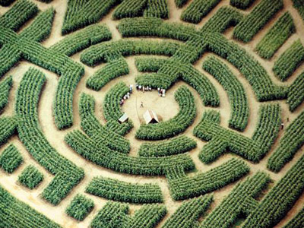
Maze or Labyrinth gardens can be created for health, entertainment, pleasure and spirituality.
By using the waste material, such as frames of windows, doors, etc., very good multi-tier urban gardens can be created. A net with 75% shade can be used in hot summers for protecting the gardens from intense heat in the summers.
Cross section

 | Plants |  | Coarse uniform Sand (2 inches) |  | Biochar Compost (6 to 8 inches)
 | Black Plastic Sheet |  | Bricks

The top of the rooftop should be protected from water seepage into the building. For this purpose a layer should be coated with waterproof cement. Water proof paint can also be used after completing the layer. A rectangular bricks-wall should be created as a bin and inlaid with plastic sheet. Sloping porous pipes are placed inside the sand from the bottom for drainage of excess water. In the walk ways pebbles would be great for convenience of dryness, easy flow of water and as acupressure for the feet while walking.
Water
For watering the plants periodically a sink with flush fitted to a selected water container can be used. Drip irrigation is also a good choice.
Plants:
All types of seeds could be sown or planted. Starting from tubers, herbs, shrubs, bushy plants, medium size plants, creepers, runners, lianas, etc. In between the plants edible or ornamental fish ponds could be created. Preferably the diversity and density of the plants should be high.
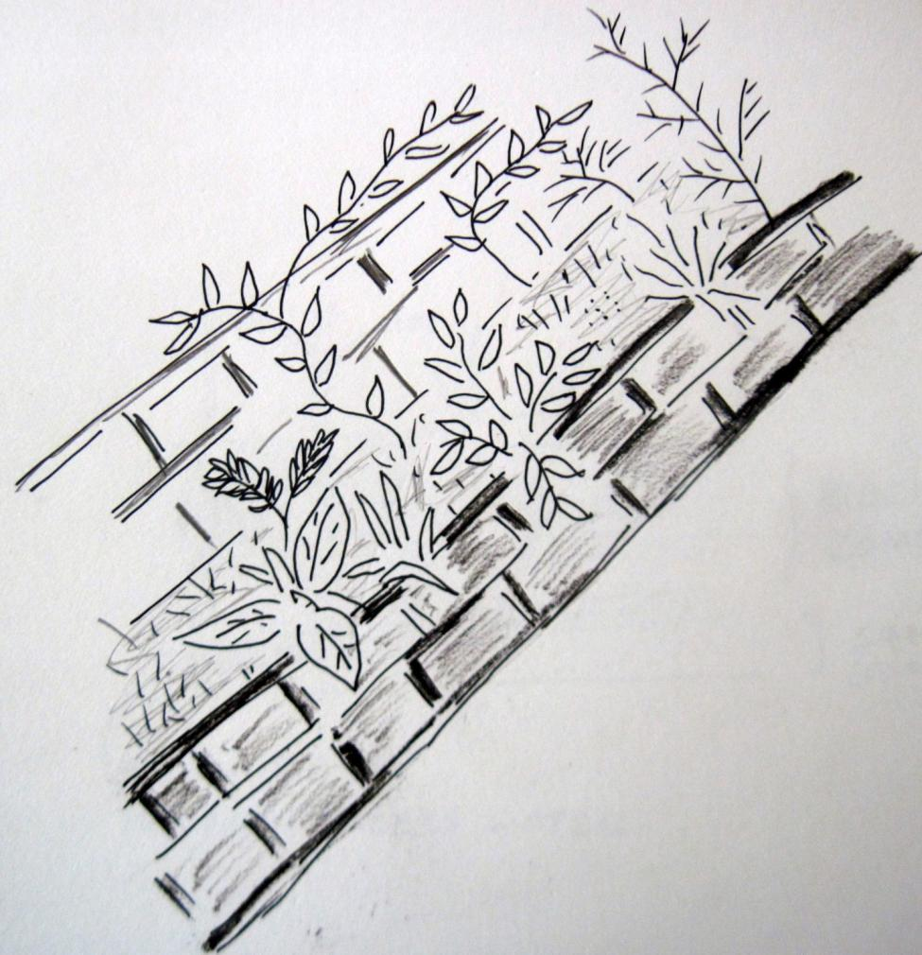

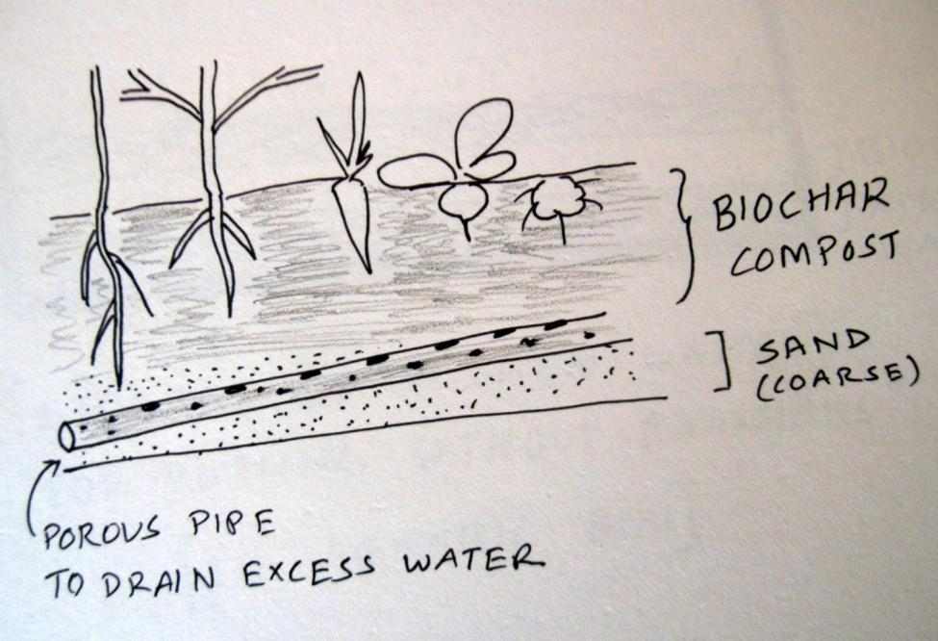

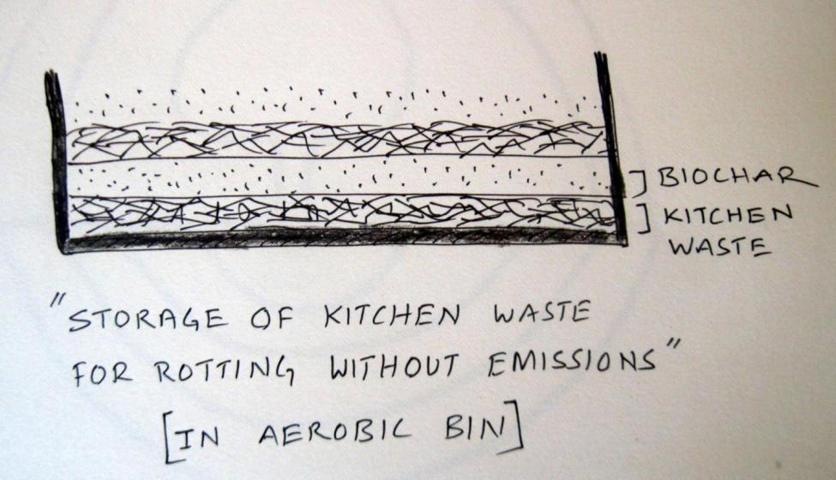
Advantages of Biochar Urban Gardens:
- These are low cost solutions for efficient use of urban spaces.
- Complement food needs by growing food.
- Fresh and nutritious food is available close to habitation
- Economic savings through access to self grown food
- Utilization of waste for creating biochar compost. Carbon sequestration through biochar use. Emissions reduction, improved soil fertility and management, efficient use of water and conservation, increased soil microbial density, micorhazea (fungus), etc. Sink for CO2 and contribution to climate change mitigation.
- Converting dry waste into biochar using biochar stoves and utilizing the energy. http://goodstove.com
- Efficient solid waste management
- Insulation to the roof
- Entertainment and cultural activity space
- Social gathering
- Conducting meetings and workshops
- Health walk ways
- A great place for exercise and mental peace.
- Aesthetics

References:
OPEN IDEO http://www.openideo.com/profiles/100000246930438/contributions.html
http://biocharindia.com
http://e-terrapretarooftopexp.blogspot.com/

Dr. N. Sai Bhaskar Reddy, CEO, GEO
saibhaskarnakka@gmail.com
http://e-geo.org
09246352018 | 09505760669

